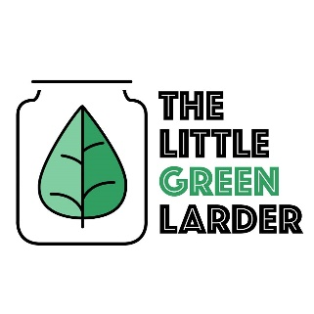

The Little Green Larder The Little Green Larder

Cajun chick pea burger with wedges Cajun chick pea burger with wedges

Garlic  
Onion  
Carrot  
Courgette  
Chickpeas  
Cajun spices  
Potato   
Paprika spice mix

- Soak chickpeas for 4 – 8hours (we just leave them overnight), rinse then place in a pot of water. Bring to boil then simmer for 1 hour. Drain and set aside

- Cut potatoes into wedges and place on a baking tray. Lightly drizzle over some oil and sprinkle on the wedge spice mix. Cook at 200/ gas mark 6 for 15 – 20 mins

- Grate the carrots and courgette, squeeze excess water out with a towel or napkin

- Blend/ mash chickpeas until they are coarsely mashed, but not to a paste.

- Chop the onion and 2 – 4 garlic cloves, fry with the Cajun spice mix for 2- 4 mins

- Combine all of the ingredients in a bowl, add salt and pepper to taste. Form into burgers and fry in oil for 5 mins each side

- Serve and enjoy

Serves 2 Serves 2

Garlic  
Onion  
Carrot  
Courgette  
Chickpeas  
Cajun spices  
Potato   
Paprika spice mix

- Soak chickpeas for 4 – 8hours (we just leave them overnight), rinse then place in a pot of water. Bring to boil then simmer for 1 hour. Drain and set aside

- Cut potatoes into wedges and place on a baking tray. Lightly drizzle over some oil and sprinkle on the wedge spice mix. Cook at 200/ gas mark 6 for 15 – 20 mins

- Grate the carrots and courgette, squeeze excess water out with a towel or napkin

- Blend/ mash chickpeas until they are coarsely mashed, but not to a paste.

- Chop the onion and 2 – 4 garlic cloves, fry with the Cajun spice mix for 2- 4 mins

- Combine all of the ingredients in a bowl, add salt and pepper to taste. Form into burgers and fry in oil for 5 mins each side

- Serve and enjoy